**Partial View in MVC**

**Introduction to MVC Partial View**

Partial view in ASP.NET MVC is a special view that renders a portion of view content. It is just like a user control of a web form application. Partial can be reusable in multiple views. It helps us to reduce code duplication. In other word a partial view enables us to render a view within the parent view.

The partial view is instantiated with its own copy of a ViewDataDictionary object which is available with the parent view so that partial view can access the data of the parent view. If we made the change in this data (ViewDataDictionary object), the parent view's data is not affected. Generally the Partial rendering method of the view is used when related data that we want to render in a partial view is part of our model.

Creating Partial View

To create a partial view, right-click on view -> shared folder and select Add -> View option. In this way, we can add a partial view.

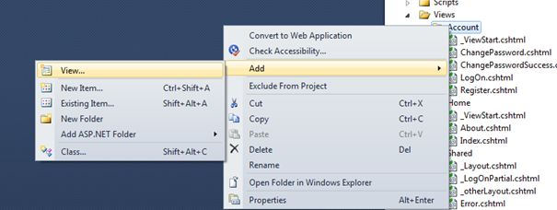

It is not mandatory to create a partial view in a shared folder, but a partial view is mostly used as a reusable component, it is a good practice to put it in the "shared" folder.

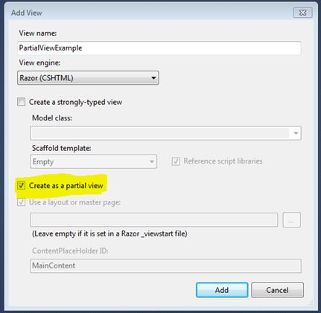

HTML helper has two methods for rendering the partial view: Partial and RenderPartial.

<p>

@Html.Partial("PartialViewExample")

</p>

<p>

@{

Html.RenderPartial("PartialViewExample");

}

</p>

**@Html.RenderPartial**

The result of the RenderPartial method is written directly into the HTTP response; it means that this method used the same TextWriter object as used by the current view. This method returns nothing.

**@Html.Partial**

This method renders the view as an HTML-encoded string. We can store the method result in a string variable.

The Html.RenderPartial method writes output directly to the HTTP response stream, so it is slightly faster than the Html.Partial method.

Returning a Partial view from the Controller's Action method.

public ActionResult PartialViewExample()

{

return PartialView();

}

**Render Partial View Using jQuery**

Sometimes we need to load a partial view within a model popup at runtime. In this case, we can render the partial view using the JQuery element's load method.

<script type="text/jscript">

$('#partialView').load('/shared/PartialViewExample’);

</script>

View Vs Partial View

|  |  |
| --- | --- |
| **View** | **Partial View** |
| View contains the layout page | Partial view does not contain the layout page |
| _viewstart page is rendered before any view is rendered | Partial view does not check for a _viewstart.cshtml. We cannot place any common code for a partial view within the _viewStart.cshtml page. |
| View may have markup tags like html, body, head, title, meta etc. | The Partial view is specially designed to render within the view and as a result it does not contain any mark up. |
| Partial view is more lightweight than the view. We can also pass a regular view to the RenderPartial method. |  |
| If there is no layout page specified in the view, it can be considered as a partial view. In razor, there is no distinction between views and partial views as in the ASPX view engine (aspx and ascx). |  |